**The Bridge is OUT!**

**Intro:**

One day, on their ways to trade with a long-time ally, the enemy tribes of the Purple Raccoons, Blue Squirrels, Red Wolves, and the Green Jackals find that the bridge to get to their ally’s camp is out. Seeing this, and each other, they decide that they will each build their own bridge (though they clearly don’t know how to do such a thing as they are all merchants). Knowing the places that their ally tribe told them each to trade at, they begin to build their own bridges to get there. The only issue is that they’ll have to cross in front of each other in order to get to the place they need to be…

INSTRUCTIONS

Number of Players:

2 – 4

Components:

* The ravine (GAME BOARD).
* The **4** tribe merchants (GAME PIECES) of your tribe’s color.
* **20** BRIDGE BOARD PIECES of your tribe’s color.
* The **two** **card decks**: ACTION CARDS (Yellow) and PLAYER CARDS (**Purple, Blue, Red, and Green**).
* One **D-4** and One **D-6**.

Set up:

1. Pick your preferred tribe.
   1. If there are only two tribes participating in the game, players may only pick Purple and Blue OR Red and Green.
   2. If there are only three tribes participating, players may only pick Purple, Blue, and Green, OR Green, Red, and Purple.
2. Situate your bridge board pieces in a pile in front of you.
3. Set your tribe merchant(s) on their start spot.
4. Put the two card decks face-down next to the board.
5. Players draw two Action Cards to hold onto.

How to Start:

The player whose birthday comes next goes first. After that, play order goes clockwise.

On your first turn:

1. Roll the **D-4** to determine how many **cards** you can pick.
2. Take the number of cards you rolled, choosing from the Player card deck and read what they say.
   1. Ex: I rolled a 3 so I grab three cards.
3. Do what the cards tell you, and once you do, put them at the bottom of the card deck. **Do not keep cards once you’ve used them**.

On Your Turn:

You have two options:

1. Roll the **D-4** to **pick cards** from the Player card pile.
   1. These cards are the **Purple, Blue, Red, or Green** cards; when you get one, immediately put that amount of bridge boards down on your bridge
   2. Once you follow the directions of the card, put it back at the bottom of its deck.
2. Roll a **D-6** and **move** one of your merchants that amount of **spaces**.

* After either option, you may do this, given that you have not done this less than three turns prior: Use an Action card on another player, placing it at the bottom of its deck and drawing another Action card to replace it once your turn is up.

Rules:

Each component of the game has specific rules. The biggest thing to remember about the game is that YOU DO NOT LIKE THE OTHER TRIBES. Do not share anything with anyone else. Anything of your color is strictly your own, and no one else’s (except Player cards in some cases).

Cards:

There are two different types of card decks. Each has their own functions and restrictions.

* **Player Cards:** 
  + These cards are Purple, Blue, Red, and Green, and they have one number on them, ranging from 1 to 4.
  + The number on these cards tells you how many of your boards you can put down at a time to build your bridge.
  + Regardless of the color of the card, you only place down YOUR COLOR of bridge pieces.
    - Ex: if my color is blue, and I draw a red 2, I put down two blue bridge pieces.
  + To learn the game and for quicker-paced play, you can use any color of cards.
  + For harder, even more competitive play, you can only use your color cards, whether you or another player draws it.
    - Ex1: if my color is blue again, and I draw a red 2 again, the player with red boards puts down two boards and I do nothing.
    - Ex2: if my color is still blue, and I draw a blue 4, then I can put down four blue boards
    - Ex3: if my color is still blue, and another player draws a blue 3, I can then put down three blue boards.
* **Action Cards**:
  + These cards are Yellow, and they have instructions on them.
  + There are two different types of action cards, **Sabotage** and **Switch**, each with their own set of rules as well.

* + Sabotage cards:
    - These cards give players the ability to “destroy” another of ONE tribe’s bridge boards.
    - The cards will tell you how many boards to take away.
    - When boards are taken away, just give them back to the player who had originally placed them so they can use them again.
    - You do **NOT** replace the sabotaged boards with your own. These cards are strictly for punishing and messing with other players.
    - Two sabotage cards means you can sabotage possibly two different tribes.
    - You can sabotage boards **ANYWHERE** on the board.
  + Switch cards:
    - These cards give players the ability to “switch” one of their boards with one of another player’s boards.
    - The main rule of these cards is that it applies only to boards that are already on a bridge. You can’t switch one of your still unused boards with another player’s. Otherwise, it wouldn’t be a switch.
    - If you want, instead of switching one of your own boards with one of another player’s, you can switch other tribes’ boards with each other.
    - You must put boards down **BEFORE** switching them.

*Important Notes:

- You can’t hold Player cards.

- You can not switch between using cards. Ex: if you have a Sabotage 3 and a “player card” that reads 4, you can’t put down 3 boards, sabotage 2 boards, and then go back to the player card and put down your last bridge piece.

- **Players can only use Action cards once every THREE turns.**

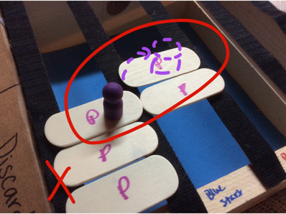Movement:

When you roll the D-6, and move forward…

* The number on the die tells you how many spaces a merchant CAN move (a space is one board piece) in the succession of your bridge.
* You only have to move your merchant an amount of spaces in the parameters of the number on the dice.
* Movement CAN be split between multiple merchant pieces.
* Merchants can not move diagonally.
* You can NOT move and draw cards. You can play HELD cards and move.

Boards:

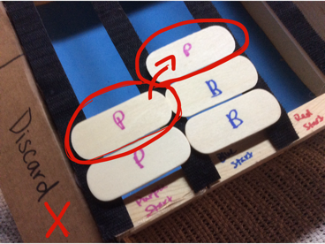There are rules for board placement as well as board physics in order to make this game a lot more interesting.

* **Boards can not be placed diagonally** from each other. They must connect either forward or straight across when crossing into another lane. You don’t expect merchants to know how to jump, do you?
* Because these merchants are dumb, they are building their bridges while crossing it at the same time. So, if a board is sabotaged while a merchant piece is on it, that merchant piece will be sent **BACK** to the next furthest board piece of the bridge.
* You can place your boards anywhere on the board as long as they come consecutively. To put it more simply, **don’t just put a board anywhere**. On the other hand, if one is stuck in the middle of the board because others around it were “destroyed”, then that is fine.
* You can only walk **on your color** boards. You can’t go onto another color.
* You can’t use another color board. **You can only use your own**.
* Again, once boards are sabotaged, **give them back** to the player who owns them so that they can be reused.
* 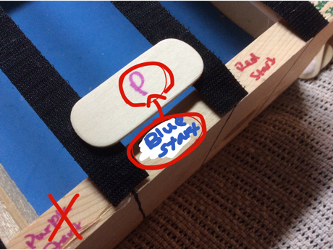You have to put your boards **next to ones of the same color**, because again, you’re only using your color boards.
* There are **10 boards** (at the least) needed to cross the ravine, as the ravine is nine boards across, and you will need to cross into another lane at least once.
* When placing boards, the **first board** you place must be in front of your **“start”**, and the **last board** you place must be in front of your **“finish”**.

How to Win:

All you have to do to win is get all of your merchants (or merchant) to the other side of the ravine first. The game can continue if players want to have a second and third place as well.

Easy (Quick) Play Rules:

* Any color of the Player cards can be used for board placement.
* You only need to move one merchant to the other side.
* Merchants only go back to the board (behind them) that is furthest along when the board they were on before is sabotaged.

Medium Play Rules:

* You can only put boards down when one of your colored Player cards is picked (whether you or another player draws that card).
* You need to move two merchants to the other side.
* Merchants go back to the board that furthest along like in Easy Play.

Hard (Long) Play Rules:

* You can only put boards down when one of your colored Player cards is picked, like in Medium Play.
* You must get all four merchants to the other side.
* Merchants go back to their start when the board they were on before is sabotaged.
* 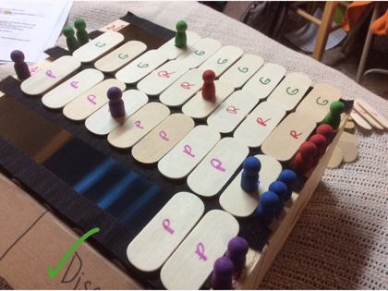Players have 15 minutes to play the game.
* Once time is up, whoever has the most merchants on the other side of the bridge wins. If there are no merchants to be counted, whoever has the most boards in their bridge wins.

Sample of how a game board should look mid-game.